TODAY COHORT TASK

NAME:D.SAI CHARAN
PIN :25B25A4222
BRANCH:CSM(AIML)

. What is SLM (Small Language Model)?

A Small Language Model (SLM) is an AI model designed to understand and generate human language using fewer parameters than a Large Language Model (LLM). It is optimized for efficiency, lower resource consumption, and faster response times.

Key Features
- Smaller model size
- Faster inference
- Lower memory and computational requirements
- Cost-effective deployment
- Suitable for edge devices and local systems

Use Cases
- Chatbots
- Mobile applications
- Virtual assistants
- Enterprise automation

Summary
SLMs provide efficient and affordable AI solutions for domain-specific tasks while requiring fewer resources than LLMs.

2. What is a RAG (Retrieval-Augmented Generation) System?
Retrieval-Augmented Generation (RAG) is an AI architecture that combines information retrieval with language generation. It retrieves relevant information from external data sources and uses that information to generate accurate responses.

Components
- Data Source
- Embedding Model
- Vector Database
- Retriever
- Language Model (LLM/SLM)

Benefits
- Improves answer accuracy
- Reduces hallucinations
- Provides up-to-date information
- Supports enterprise knowledge retrieval

Summary
RAG enhances AI systems by allowing them to access external knowledge before generating responses.

3. Difference Between LLM and SLM?

Feature | LLM (Large Language Model) | SLM (Small Language Model)
Model Size | Large | Small
Parameters | Billions/Trillions | Millions/Billions
Resource Usage | High | Low
Cost | Expensive | Cost-Effective
Speed | Slower | Faster
Reasoning | Strong | Moderate
Deployment | Cloud-Based | Edge/Local Devices
Knowledge Coverage | Broad | Limited

Summary
LLMs offer advanced reasoning and broader knowledge, while SLMs provide faster and more efficient performance with lower resource requirements.

4. How RAG Works with LLMs and SLMs?

Workflow
- User submits a query.
- Query is converted into embeddings.
- Vector database searches for relevant information.
- Relevant documents are retrieved.
- Retrieved content is added to the prompt.
- LLM or SLM generates the response.
- Final answer is returned to the user.

RAG + LLM
- Better reasoning
- Handles complex queries
- Higher infrastructure cost

RAG + SLM
- Faster responses
- Lower deployment cost
- Suitable for edge devices

Summary
RAG improves both LLMs and SLMs by providing external knowledge, resulting in more accurate, reliable, and context-aware responses.

● GitHub account(screenshots)

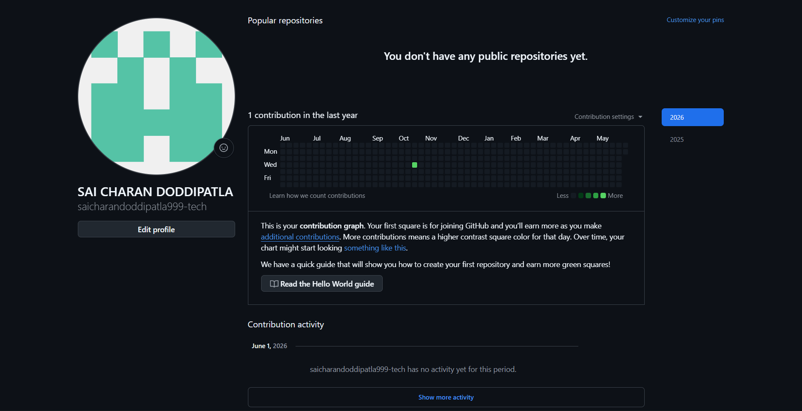

● Installed tools VISUAL STUDIO CODE (Screenshots)

